Blyth Kayak Club
The first time kayaking on open water is an exciting and new experience for most people.
To help us ensure the first-time paddling is an enjoyable one, we ask the following:
- Ensure we have up-to-date contact numbers
- Please arrive at the club house promptly for any paddle and appropriately dressed
- We can provide the following kit:
  - Kayak
  - Paddle
  - Helmet
  - Buoyancy aid
  - Spray deck
  - Windproof top (Cag)
All borrowed kit is numbered and needs to be logged in and out on the club checklist, located on the desk in the clubhouse. This makes it easier to select your kit on the next paddle.
- What to wear – wear a number of thin layers if possible, avoid cotton and denim as both will absorb water and become very uncomfortable and cold when wet. Old trainers are a good choice for footwear.
- Have a complete change of clothing, towel and shoes for the end of the paddle
- Medication (e.g. inhalers etc) should be carried with them and let the coach know
- Have a cold or hot drink and something to eat. On a first time paddle we could be away from the clubhouse for two or three hours, so a snack and a drink is a good idea
- After the paddle, we ask all members to help rinse and put kit away correctly.

Information for parents / carers of junior members
To help us ensure our junior members have the best possible experience from their first outdoor paddle, we ask the following:
- Ensure we have up-to-date contact numbers
- Please arrive at the club house promptly for any paddle and appropriately dressed (please refer to information above)
- We ask you to stay and help your child to ensure they have the correct kit and that it is checked for size by a coach
- There are occasions when juniors do not enjoy their first experience on open water. For this reason, we ask that an adult accompany the child if possible, to stay on the beach or riverbank and to assist or take the child home early. If this is not possible please ensure we are aware of this and we have a contact number and that an adult is available to collect the child quickly if necessary.
Thank you for your help and support, we hope you will have a positive and very enjoyable paddling experience.
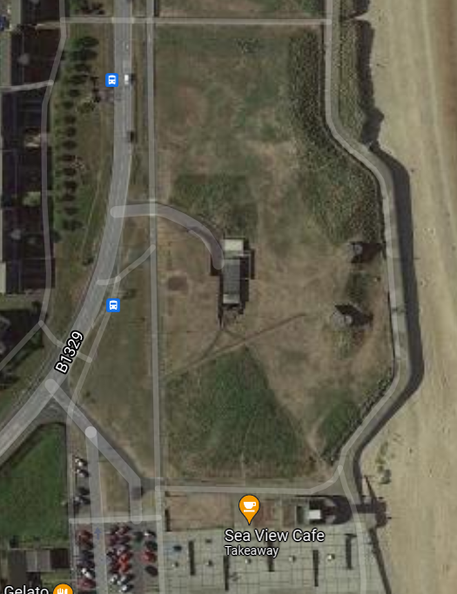
The clubhouse is located just north of the large car park next to Blyth Beach Huts. There is limited parking at the club house.

